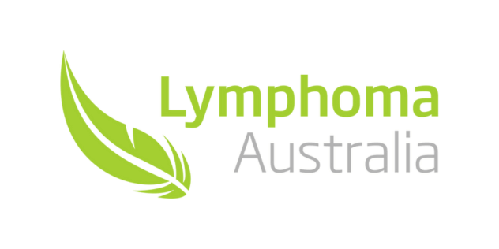

**Lymphoma.org.au**

**1800359081**

**fundraise@lymphoma.org.au**

**RE: Limelight Event**

To Whom It May Concern,

Every year 7,400 Australians are diagnosed with lymphoma – that is 20 adults and children each day. Lymphoma is the number one cancer in young people and has over 80 different subtypes. Tragically, 1,700 die from lymphoma each year. There is no known cause and no pre-screening tests.

Lymphoma Australia is planning to put lymphoma in the limelight to commemorate World Lymphoma Awareness Month in September and specifically on World Awareness Day, Friday the 15th. More information can be found here – https://www.lymphoma.org.au/get-involved/lymphoma-awareness-month/.

In previous years Lymphoma Australia has successfully lit up several famous landmarks green. However, the aim for 2023 is to light up as many landmarks across the nation as possible – putting lymphoma into the limelight in all capital cities, as well as rural and regional towns.

As a supporter of those touched by lymphoma and a local resident, I would appreciate you considering the possibility of lighting up one or more of our local landmarks in support of World Lymphoma Awareness Month.

Sincerely,

(name)

(email)

(phone)

Ambassador for Lymphoma Australia Limelight Event